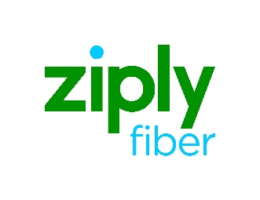

SONET Facility Inquiry Form

The SONET Facility Inquiry Form provides a resource to request information on existing SONET Ring and associated node assignments for the Ziply Fiber footprint. The inquiry request has two (2) options available:
- SCID assignment associated to the SONET Facility
- SONET Facility
Frontier has 48 business hours to return the expected data.

Populate one (1) of the options: SCID or SONET Facility

SONET Facility SCID assignment:

OR

SONET Facility:

Facility Facility
Designation Type A Location Z Location

Populate Customer information fields:

Request Date: Carrier CCNA:

Company Name:

Requestor Name:

Requestor Telephone #:

Requestor E-mail Address:

E-mail completed form to your Account Manager.
Note: If you are unaware of your assigned Account Management team, please send email to wholesale@ziplyfiber.com

